Sprint Review and Retrospective

Brittney Jackson
Department of Computer Science, Southern New Hampshire University
CS 250: Software Development Life Cycle
Professor Parul Hirpara
October 14, 2023

Sprint Review and Retrospective

Roles
I donned multiple hats in our Scrum-Agile project, including Scrum Master, Product Owner, Tester, and Developer. These roles were not just titles; they were the driving forces behind our project's success. As the Scrum Master, I orchestrated Scrum-Agile meetings, fostering collaboration, optimizing efficiency, and maintaining focus. I ensured our team understood user stories and priorities during sprint planning. Each day began with impactful stand-up meetings where progress and roadblocks were discussed, ensuring swift issue resolution and sprint goal alignment. As the Product Owner, I gathered user stories and feedback, carefully documenting everything in the product backlog. The prioritization of these stories and the creation of detailed user story charts offered a roadmap for the development team. My dual role as a Developer and Tester facilitated smooth transitions and the highest application quality. Effective communication between the Product Owner, Tester, and Developer was essential, and it ensured a seamless process. Regular meetings and open communication channels clarified new requirements, and updates to test cases were seamlessly incorporated.

Completing User Stories
Our Scrum-agile approach was pivotal in completing user stories in the SNHU Travel project. By breaking down user needs into manageable tasks through user stories, we defined specific tasks and prioritized them based on urgency. For example, the user story of customizing the top destination list involved creating a drop-down menu for vacation types and generating recommendations based on user preferences. These tasks were completed within the sprint, ensuring the user story's successful completion.

Handling Interruptions
This approach allowed us to adapt to changes effectively. When the project's scope changed to include detox/wellness travel requirements, we reorganized the backlog, reprioritized user stories, and adjusted our sprint planning to accommodate these changes without causing project delays. This flexibility ensured that the project continued smoothly despite interruptions.

Communication
We facilitated effective communication between the team and users primarily through the product backlog, which allowed us to track completed and pending tasks, priorities, and overall project status. Without a product backlog, there's a risk of tasks being forgotten or misunderstood, which could lead to project delays. I included screenshots that capture our approach's essence to offer a deeper look into our project's communication strategies. Take, for instance, the screenshot showcasing User Story Number 2, where we aimed to create a "Customizable Top Destination List" to deliver tailor-made travel recommendations based on users' preferences. The associated acceptance criteria spell out the specifics of this user story. Another significant aspect of our project's communication was our adept use of the product backlog.
As you can see in the provided screenshot, the product backlog was the backbone of our clear communication and collaboration within the Scrum Team. It allowed us to stay on top of tasks, prioritize effectively, and maintain a bird's-eye view of the project's status. For instance, consider User Story 2 in the product backlog, emphasizing the importance of customization based on travel preferences and history. This is where our proactive communication journey kicked off, forging a connection between user desires and project objectives.
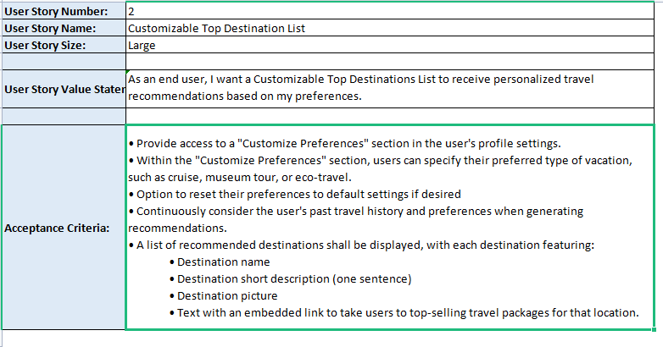
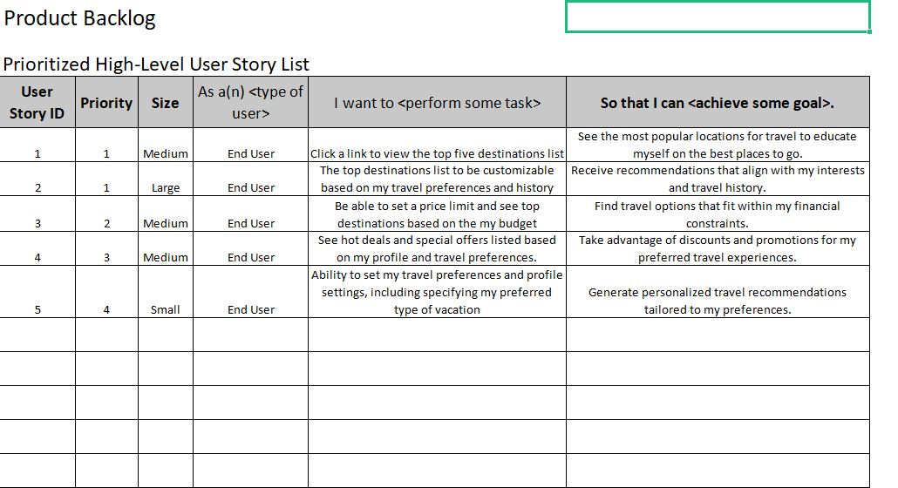

Organizational Tools
The organizational tools and Scrum-Agile principles significantly contributed to our team's success. We extensively used the product backlog to track completed and pending tasks, prioritize user stories, and gain insights into the project's overall status. This tool was the cornerstone of our efficient communication. Using user stories as a structured way to document user needs and expectations allowed us to view development from the user's perspective. It was invaluable in enhancing collaboration and ensuring our product met user needs. Scrum events, such as sprint planning and backlog refinement, further enhanced our ability to prioritize tasks and maintain focus.

Evaluating Agile Process
In evaluating the Scrum-agile process for the SNHU Travel project, it's clear that its adaptability was a significant asset, enabling the project to navigate interruptions and shifts in focus smoothly. When the project transitioned from focusing on niche vacation packages to detox/wellness vacations, the Scrum-agile approach facilitated the reorganization of the backlog and the reprioritization of user stories, ensuring that the project stayed on track without causing delays. Transparency was another valuable advantage of this approach, as it fostered open communication and ensured that the entire team was well-informed about project status and challenges. This transparency not only enhanced collaboration but also reinforced individual and collective accountability. Additionally, the Scrum-agile approach allowed for incremental progress, enabling the team to deliver value step by step. Each sprint resulted in potentially shippable increments, which kept users engaged and provided tangible evidence of progress.
However, it's essential to acknowledge that adopting the Scrum-agile methodology presented challenges. This approach is less structured than traditional methodologies like the waterfall model. This lack of rigid structure can sometimes make it more challenging to predict time lines and outcomes accurately. While the benefits outweighed these challenges for our project, teams must be aware of and address potential issues when applying the Scrum-agile approach.

